**Initio Programming:** **Getting Started**

**AIM:** After following this worksheet you should be able to connect a keyboard, mouse and monitor to your Initio robot and switch it on ready for use.

Your Initio robot has several USB ports, an HDMI port and a micro USB port.

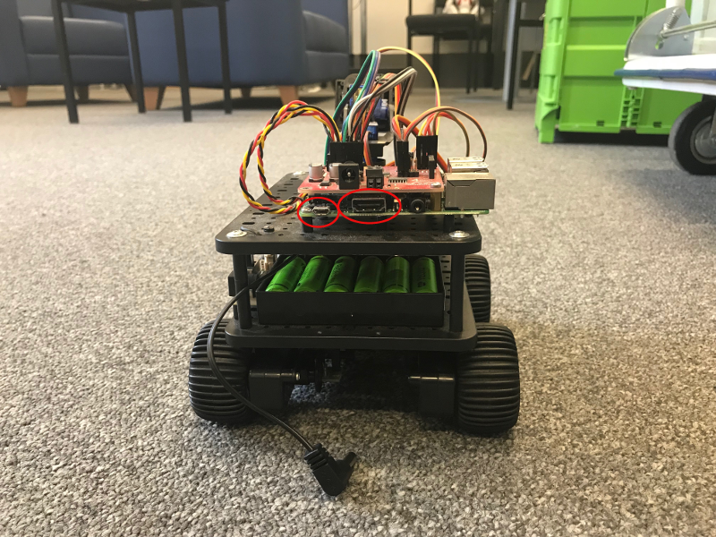

HDMI and Micro USB port locations

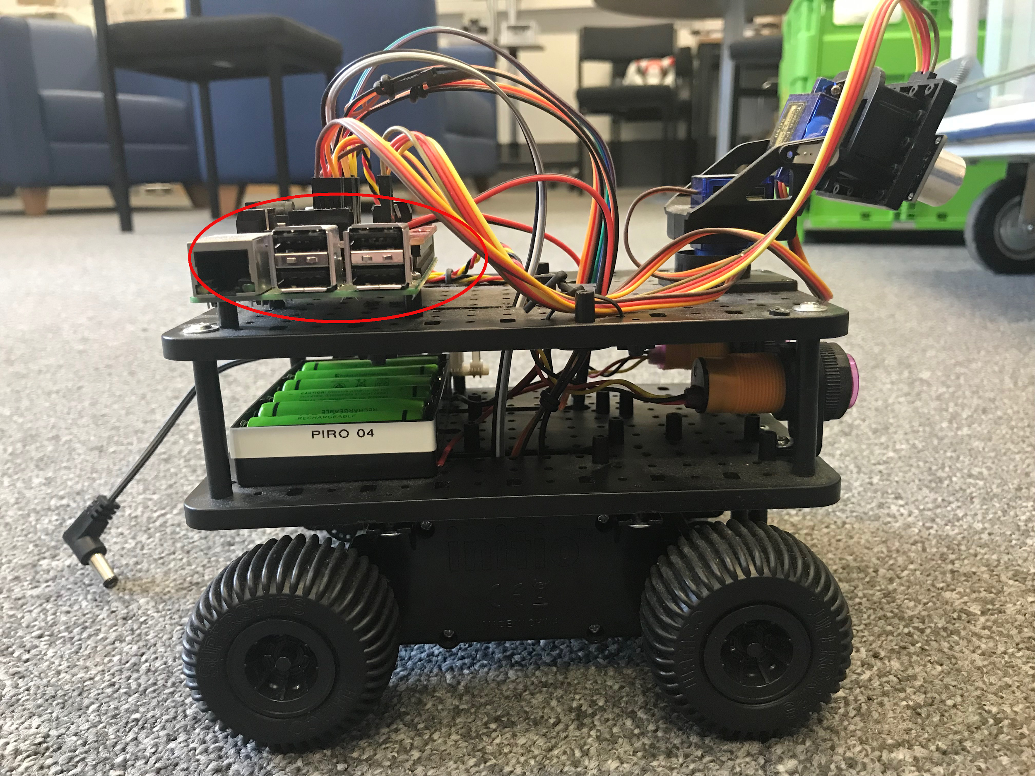

USB Ports

You should **connect your monitor** to the HDMI port and **your keyboard and mouse** to two of the USB ports.

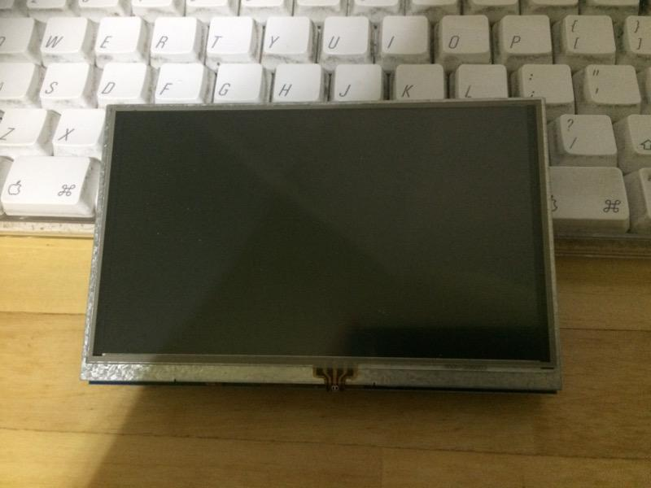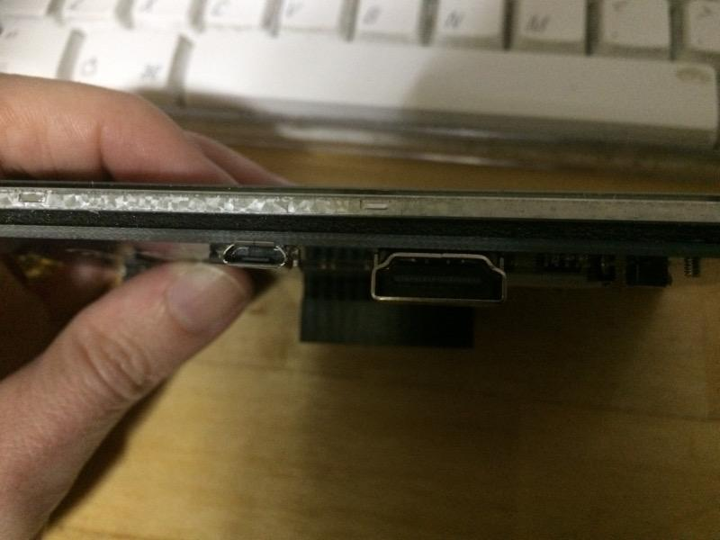

The Elecrow 5 inch monitor: USB port (for power) and the HDMI Port

If you are using the Elecrow 5 inch monitor then it can be powered from the Initio. Connect one of the USB ports on the Initio to the Micro USB port on the monitor.

If you also have an external power supply it can be connected to the Micro USB port on the Initio.

**Switch your robot on using the On/Off Switch.**

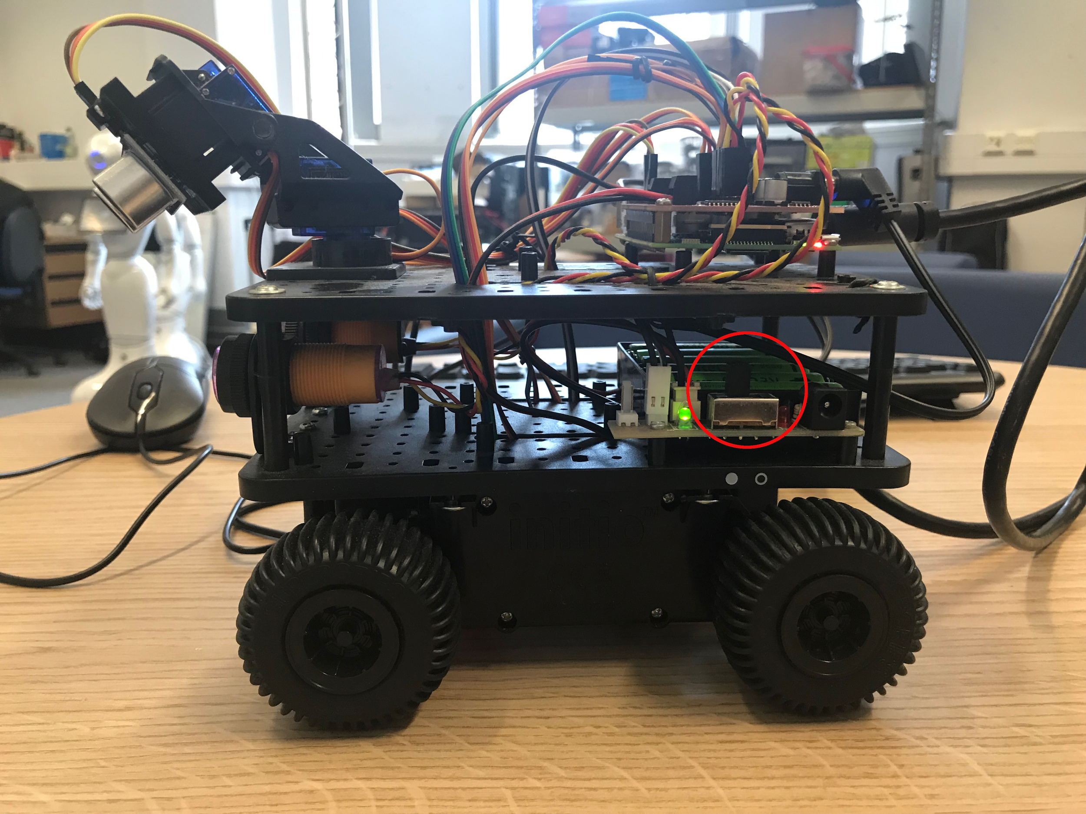

The On/Off Switch

Your final setup should look something like this.

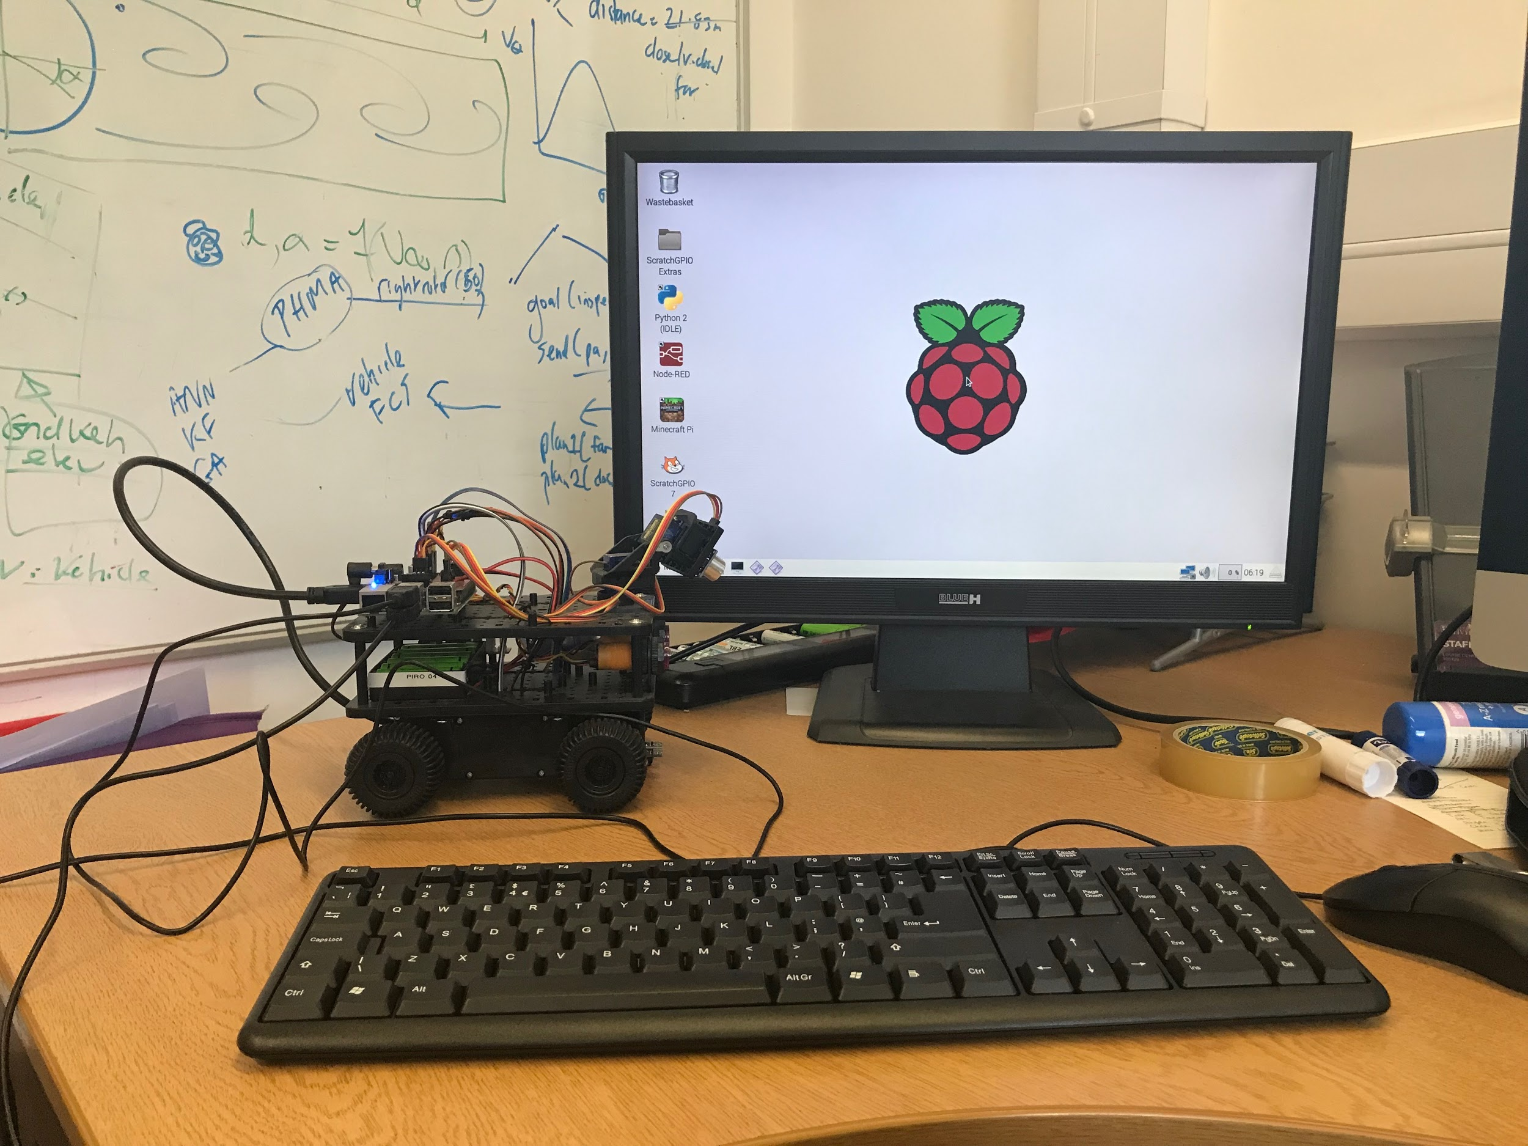

or (if you are using the Elecrow 5 inch monitor):

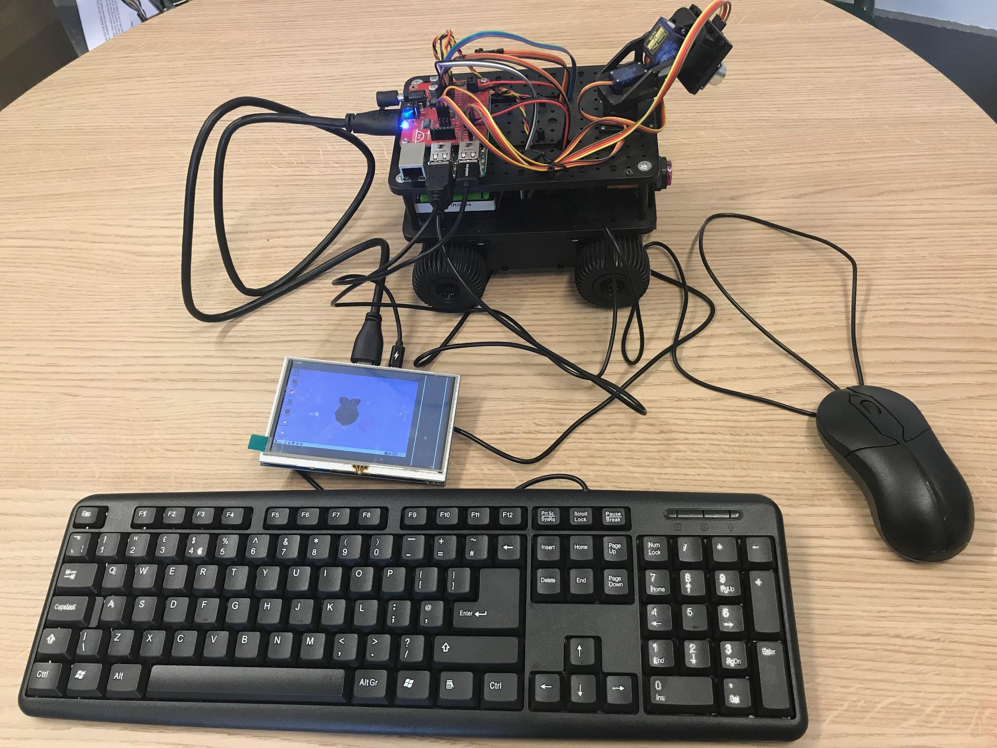



University of Liverpool, 2019

This work is licensed under a [Creative Commons Attribution-NonCommercial-ShareAlike 4.0 International License](https://creativecommons.org/licenses/by-nc-sa/4.0/).